Final Project
Fourier Series & Filters in Matlab
EENG 341

Prepared for: J. Ting, Professor
New York Institute of Technology

Prepared by: V. Cavalcante, Student
New York Institute of Technology

December 23st, 2020

Part 1: Analysis & Reconstruction
- Listen to the signal. What instrument does it sound like?
- For the Signal3.wav file it sounds like a trumpet playing a single sustaining note.

- Plot the signal in the time domain using any time window of 0.01s. Make sure you see at least 3 full periods of the signal. Keep track of the time window you choose; you will use it later in the project.

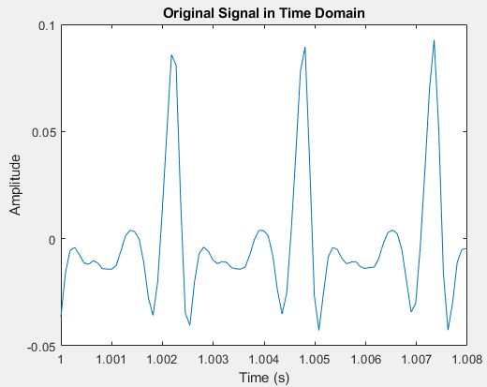

3. Plot the Fourier Transform of the signal. Choose frequency axis limits to only show the first 5 harmonics.

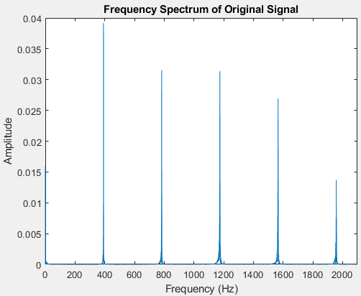

4. Is there a DC component? How can you tell by looking at the time domain plot of the signal?
- There is no DC component for a DC component is like a zero-frequency component, where there is one stable frequency. In the Time Domain Plot, we can see that the amplitude alternates, thus not stable.

5. Find the magnitude of the first 5 harmonics (up to 4 places past the decimal).

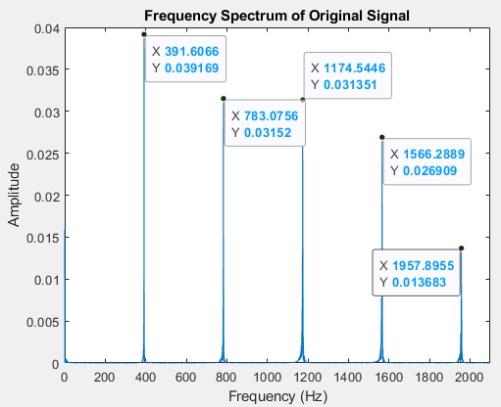

- First harmonic (391hz) = 0.039169
- Second harmonic (783hz) = 0.03152
- Third harmonic (1174hz) = 0.031351
- Forth harmonic (1566hz) = 0.026909
- Fifth harmonic (1957hz) = 0.013683

6. Plot the reconstruction of the signal using the cosine function and the following harmonics/Fourier coefficients. Choose limits on the time axis to only show 3 full periods. Assume a_{k} = a_{-k}
  - Use only the first harmonic (fundamental frequency, -1 ≤ k ≤ 1). Call this signal x1.

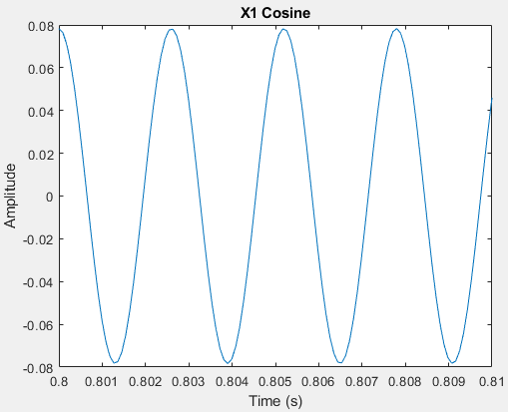

  - Plot only the first 2 harmonics (-2 ≤ k ≤ 2). Call this signal x2.
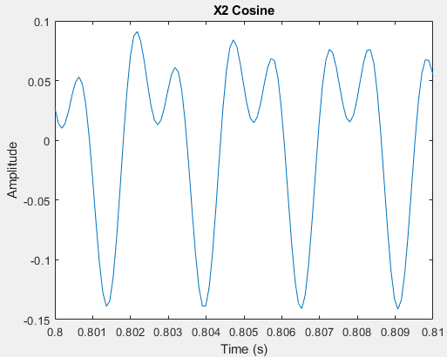

  - Plot only the first 3 harmonics (-3 ≤ k ≤ 3). Call this signal x3.
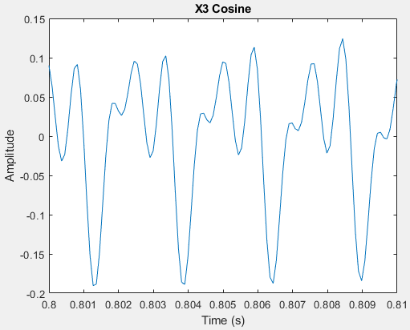

  - Plot only the first 4 harmonics (-4 ≤ k ≤ 4). Call this signal x4.
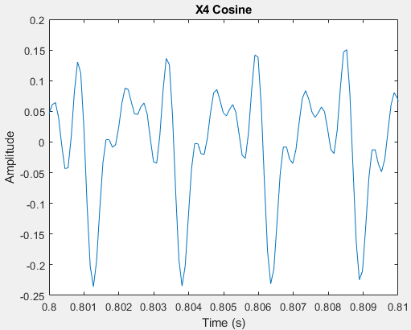

  - Plot only the first 5 harmonics (-5 ≤ k ≤ 5). Call this signal x5.
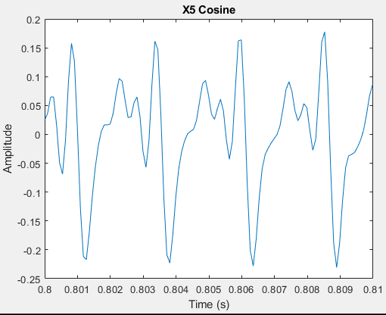

7. Plot the Fourier Transform of x5. Use the same frequency axis limits at PART 1.3. Explain similarities/differences compared to the Fourier Transform of the original signal (#3 above)? Why do the plots look different?

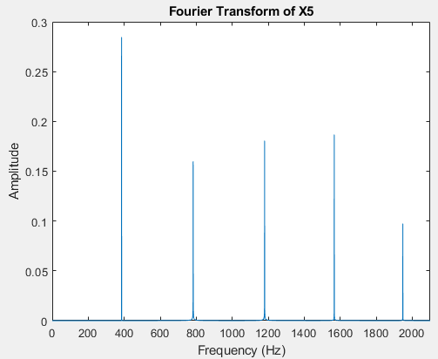

- They are similar in having the same peak frequencies but having different magnitudes at each peak. The Fourier transform of X5 and of the original signal are different because they both have different harmonic profiles, resulting in a different magnitude for each harmonic and different harmonic behavior.
Part 2: Instrument Signal filtered with 1st Order Low-Pass RC Filter, cutoff frequency = 200 Hz
- Create a 1st Order Low-Pass RC Filter, call it “h1(t).” Pick your own values for R and C (the only condition is that the capacitor be in microfarads). Recall:

  - What is the equation for the Unit Impulse Response of this filter?
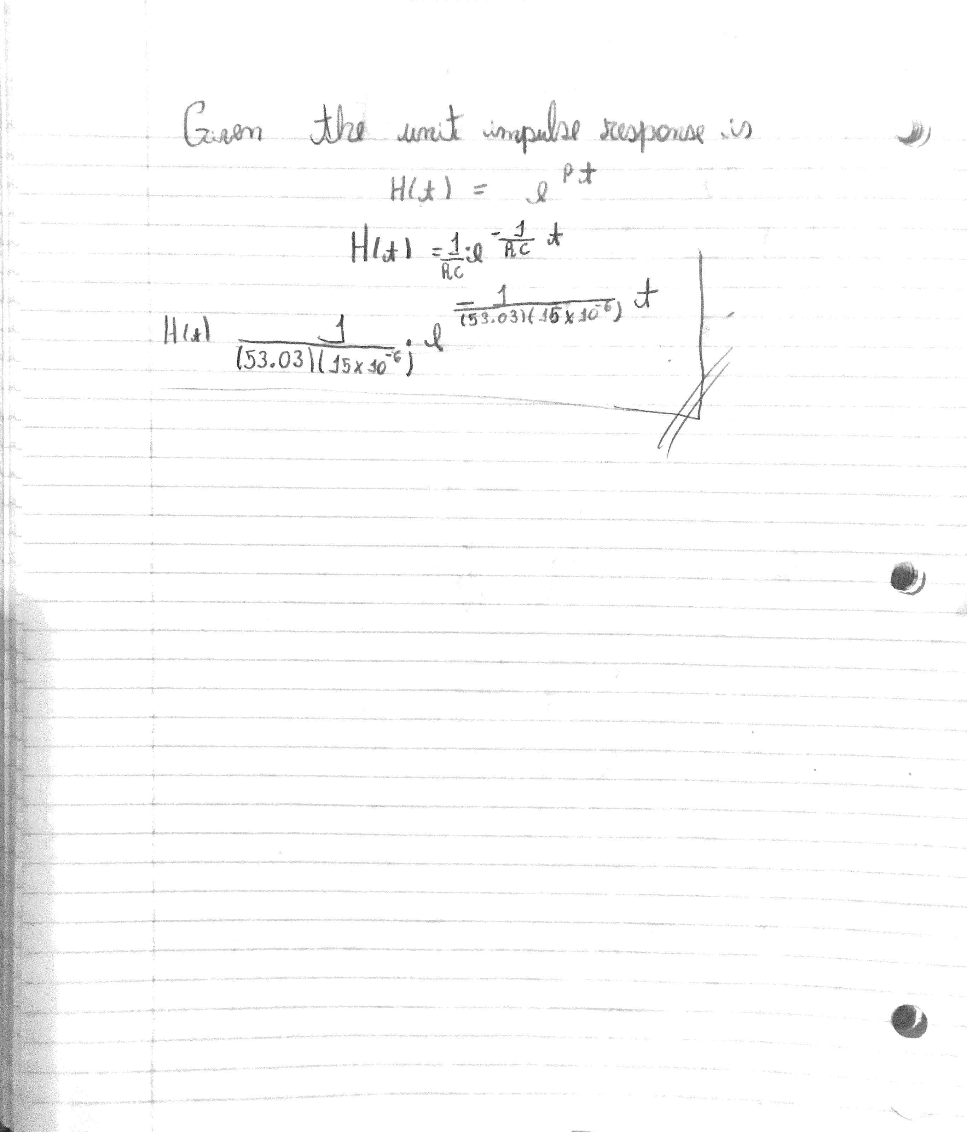

  - Plot the Unit Impulse Response in the time-domain using a window of 0 to 0.01s.

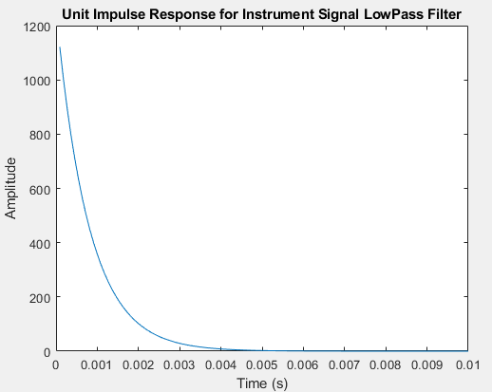

  - Plot the Fourier Transform of the Low-Pass Filter. Use the same frequency axis limits as PART 1.3.

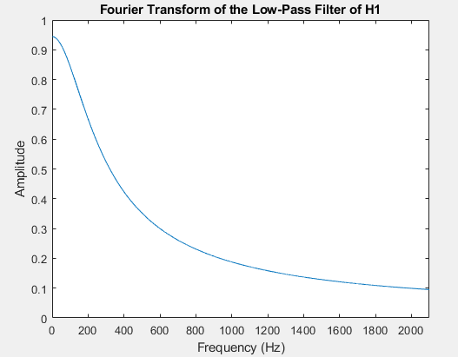

- Convolve the original signal with h1(t). Note: the convolution process reduces the overall amplitude of the output by roughly a factor of 5. So, multiply the output signal by 5 to restore the original amplitude.

  - Plot the both the original signal and the filtered signal next to each other. Use the same time axis limits as PART 1.2. How is the filtered signal different?
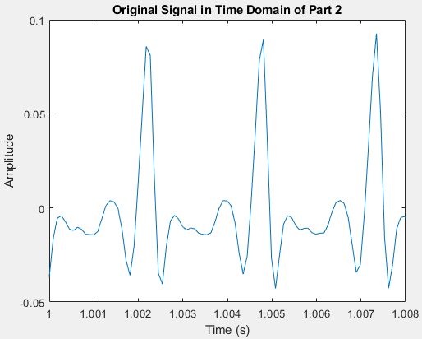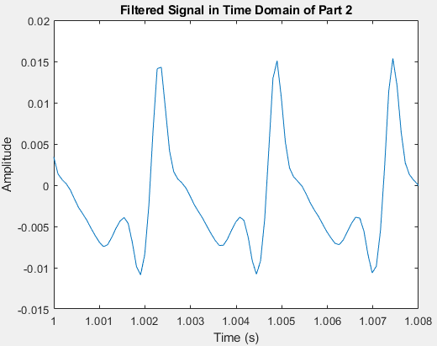

- The filtered signal narrows the amplitudes of the peaks from the original signal and compresses the signal over the time domain.

  - Plot both the Fourier Transform of the original signal and the Fourier Transform of the filtered signal next to each other. Choose frequency axis limits to only show the first 5 harmonics. How is the Fourier Transform of the filtered signal different?
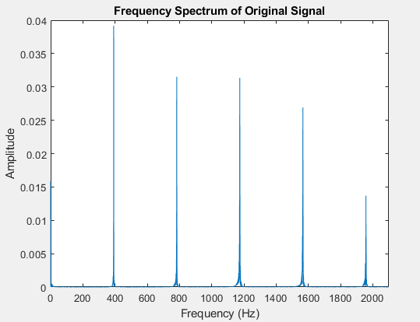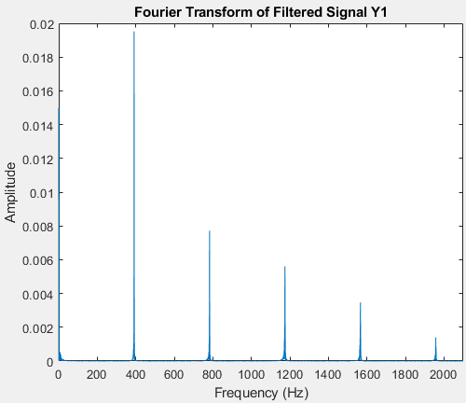

- The Fourier Transform of the filtered signal cuts off the amplitude of the upper frequency peaks when compared to the original signal.

  - So how did the filter affect the signal in the Time Domain? How about in the Frequency Domain?

- In the Time Domain the filter compressed the original signal, and in the frequency domain the peaks for the upper range are compressed as well.

  - Reconstruct the WAV signal from this filtered output signal with the “audiowrite” function. Listen to the signal. How is it different from the original signal?

- In the filtered audio sample of Signal3.wav the trumpet sound is less harsh and sounds distant from the original sound. It is not as bright as the original sound.
Part 3: Music signal filtered with 1st Order Low-Pass RC Filter, cutoff frequency = 100 Hz
- Create a 1st Order Low-Pass RC filter with cutoff frequency f = 100 Hz, call it “h2(t).” Pick your own values for R and C (the only condition is that the capacitor be in microfarads).

  - What is the equation for the Unit Impulse Response of this filter?

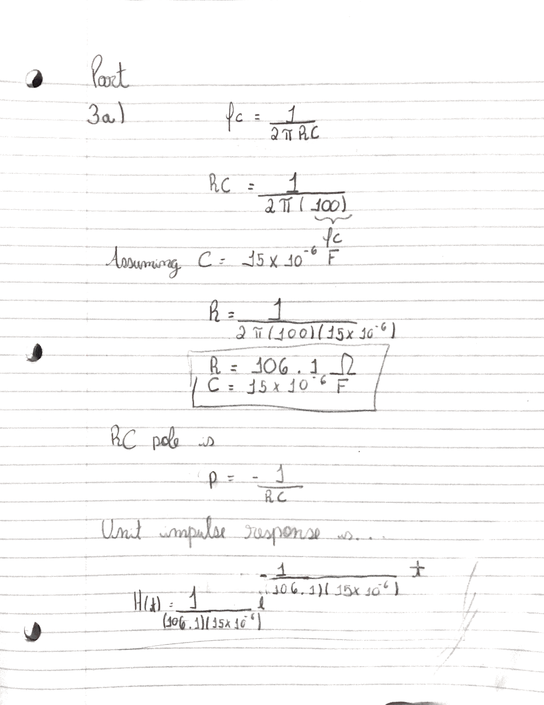

  - Plot the Fourier Transform of the Low-Pass Filter. Make 3000 Hz the max limit on the frequency axis.
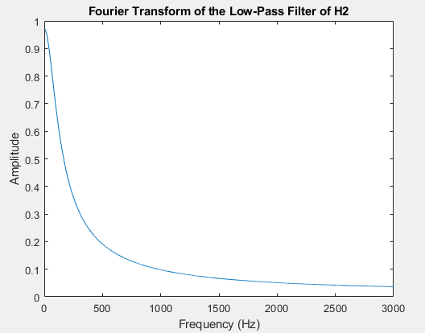

- Convolve the music signal with h2(t). Note: the convolution process reduces the overall amplitude of the output by roughly a factor of 5. So multiply the output signal by 5 to restore the original amplitude.
  - Plot both the original music signal and the filtered output signal next to each other. Choose the same time window spanning 0.05 for both plots. How is the filtered signal different?

- The filtered signal compresses the amplitude oscillation of the original signal making it more linear and controlled.

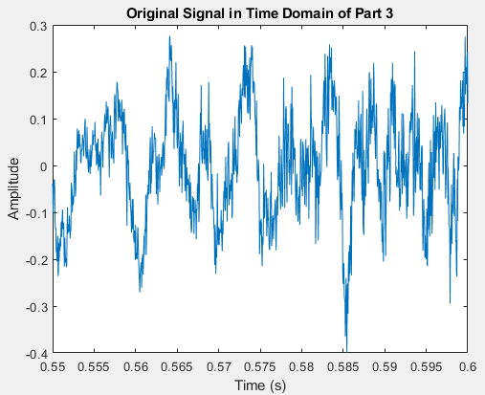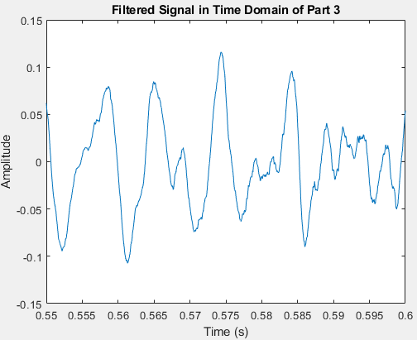

  - Plot both the Fourier Transform of the original music signal and the Fourier Transform of the output signal next to each other. Make 3000 Hz the max limit on the frequency axis. How is the Fourier Transform of the filtered signal different?

- The Fourier Transform of the filtered signal cuts off and compresses the upper frequency peaks.

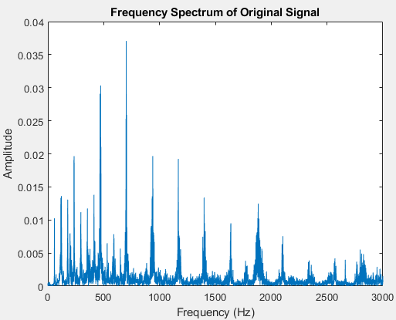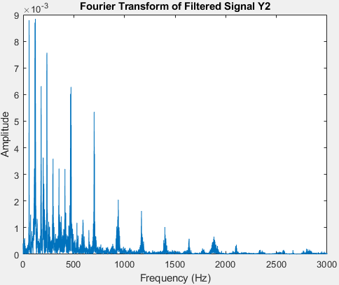

  - So how did the filter affect the signal in the Time Domain? How about in the Frequency Domain?

- In the time domain the filter compressed the original signal controlling the amplitude oscillation of the signal. In the Frequency Domain it compressed and cut down the upper frequency peaks.

  - Reconstruct a new WAV signal from this filtered output signal with the “audiowrite” function. Listen to the signal. How is it different from the original music signal?
- The filtered audio sample for Audio.wav sounds darker and less bright compared to the original sound. The cymbals and the triangle are barely audible and much less predominant.

Conclusion:

- For Part 3:
  - What is the signal and what is the system? Draw two system diagrams: one in the Time Domain and one in the Frequency Domain. Label input, output, system.

  - Which part is considered “the Filter”? What is it filtering?
- The filter is found within the system, for that is where it processes the original signal in order to get the filtered signal. The filtering consists of a 100hz low-pass filter where it compresses and cuts off all of the signals above the 100hz point, and so allowing the low frequencies to pass.

  - In the Time Domain, what is the output in terms of the input and the filter?
- The original audio sample after going through the filter will result in a filtered audio sample. In the time domain that results in a compressed output signal where it compresses the signal of the frequencies at the threshold of the low-pass filter, and cutoff of the upper frequencies.

d. In the Frequency Domain, what is the output in terms of the input and the filter?
- The original audio sample after going through the filter will result in a filtered audio sample. In the frequency domain that results in an audio sample output where the signals above the frequency cutoff will have their magnitudes compressed.
Code
close all;
clear all;

%Load File, ensure file is in same directory
%x variable will contain the data
%Fs variable is the Sampling Frequency
file = 'Signal3.wav'; %demo-signal.wav , Signal3.wav , Audio.wav
[x,Fs] = audioread(file); %read the file

Ts = 1/Fs; %Ts is Sampling Period
Nsamps = length(x); %Nsamps is the length of array x
t = Ts*(1:Nsamps); %Prepare time data for plot
%Array is the length of Nsamps in
%increments of Ts

%Do Fourier Transform
x_fft = abs(fft(x)/Fs); %Normalize the signal & Retain Magnitude
x_fft = x_fft(1:Nsamps/2); %Discard Half of Points
f = Fs*(0:Nsamps/2-1)/Nsamps; %Prepare freq data for plot

%Plot Sound File in Time Domain
figure;
plot(t, x);
xlim([1.0 1.008]); %For part2 is xlim([0.063 0.07]); %only plot t within xlim
xlabel('Time (s)');
ylabel('Amplitude');
title('Original Signal in Time Domain'); %Original Signal in Time Domain of Part 3

%Plot Sound File in Frequency Domain
figure;
plot(f, x_fft);
xlim([0 2100]); %For part 2 is xlim([0 2100]); %only plot f = 0 to 1000 Hz
xlabel('Frequency (Hz)');
ylabel('Amplitude');
title('Frequency Spectrum of Original Signal');

%Cosine
% x1 = 2* cos(10 * t);
% figure
% plot(t, x1);
% xlim([0 2]); %only plot xlim
% xlabel('Time (s)');
% ylabel('Amplitude');
% title('Cosine');

% PART 1 ------------------------------------------------------------------

%X1 Cosine
x1 = 2 * 0.039169 * cos((2 * pi * 385) * t);
figure
plot(t, x1);
xlim([0.8 0.81]); %only plot xlim
xlabel('Time (s)');
ylabel('Amplitude');
title('X1 Cosine');

%X2 cosine (will be the same as x1 for a2 is 0 for all even k's)
x2 = 2 * 0.039169 * cos((2 * pi * 385) * t) + 2 * 0.03152 * cos((2 * pi * 783) * t);
figure
plot(t, x2);
xlim([0.8 0.81]); %only plot xlim
xlabel('Time (s)');
ylabel('Amplitude');
title('X2 Cosine');

%X3 cosine
x3 = 2 * 0.039169 * cos((2 * pi * 385) * t) + 2 * 0.03152 * cos((2 * pi * 783) * t) + 2 * 0.031351 * cos((2 * pi * 1180) * t);
figure
plot(t, x3);
xlim([0.8 0.81]); %only plot xlim
xlabel('Time (s)');
ylabel('Amplitude');
title('X3 Cosine');

%X4 cosine
x4 = 2 * 0.039169 * cos((2 * pi * 385) * t) + 2 * 0.03152 * cos((2 * pi * 783) * t) + 2 * 0.031351 * cos((2 * pi * 1180) * t) + 2 * 0.026909 * cos((2 * pi * 1567) * t);
figure
plot(t, x4);
xlim([0.8 0.81]); %only plot xlim
xlabel('Time (s)');
ylabel('Amplitude');
title('X4 Cosine');

%X5 cosine
x5 = 2 * 0.039169 * cos((2 * pi * 385) * t) + 2 * 0.03152 * cos((2 * pi * 783) * t) + 2 * 0.031351 * cos((2 * pi * 1180) * t) + 2 * 0.026909 * cos((2 * pi * 1567) * t) + 2 * 0.013683 * cos((2 * pi * 1948) * t);
figure
plot(t, x5);
xlim([0.8 0.81]); %only plot xlim
xlabel('Time (s)');
ylabel('Amplitude');
title('X5 Cosine');

%Fourier Transform of X5
x5_fft = abs(fft(x5)/Fs); %Normalize the signal & Retain Magnitude
x5_fft = x5_fft(1:Nsamps/2); %Discard Half of Points
f = Fs*(0:Nsamps/2-1)/Nsamps; %Prepare freq data for plot

figure;
plot(f, x5_fft);
xlim([0 2100]); %only plot f = 0 to 1000 Hz
xlabel('Frequency (Hz)');
ylabel('Amplitude');
title('Fourier Transform of X5');

%PART 2 - Exponential function (RC Low-Pass Filter of 200hz)---------------
%Using Signal3.wav

%Unit Inpulse Response
h1 = (1/(53.03 * 15 * 10 ^-6)) * exp((-1/(53.03 * 15 * 10 ^-6)) * t);
figure
plot(t,h1);
xlim([0 0.01]); %only plot t withing xlim
xlabel('Time (s)');
ylabel('Amplitude');
title('Unit Impulse Response for Instrument Signal LowPass Filter (H1)');

%Fourier Transform
h1_fft = abs(fft(h1)/Fs); %Normalize the signal & Retain Magnitude
h1_fft = h1_fft(1:Nsamps/2); %Discard Half of Points
f = Fs*(0:Nsamps/2-1)/Nsamps; %Prepare freq data for plot

figure;
plot(f, h1_fft);
xlim([0 2100]); %only plot f = 0 to 1000 Hz
xlabel('Frequency (Hz)');
ylabel('Amplitude');
title('Fourier Transform of the Low-Pass Filter of H1');

%Convolution of Original Signal and Filter
y1 = conv(x,h1)*Ts; %multiply by interval Ts to get integral
Nsamps = length(y1); %Nsamps is the length of array y
t = (Ts)*(1:Nsamps); %Prepare time data for plot
figure
plot(t,y1);
xlim([0 2]); %only plot t within xlim
xlabel('Time (s)');
ylabel('Amplitude');
title('Convolution of Original Signal and H1');

%Plot Y1 in Time Domain
figure;
plot(t, y1);
xlim([1.0 1.008]); %only plot t within xlim
xlabel('Time (s)');
ylabel('Amplitude');
title('Filtered Signal in Time Domain of Part 2');

%Fourier Transform of Y1 (Filtered Signal)
y1_fft = abs(fft(y1)/Fs); %Normalize the signal & Retain Magnitude
y1_fft = y1_fft(1:Nsamps/2); %Discard Half of Points
f = Fs*(0:Nsamps/2-1)/Nsamps; %Prepare freq data for plot

figure;
plot(f, y1_fft);
xlim([0 2100]); %only plot f = 0 to 1000 Hz
xlabel('Frequency (Hz)');
ylabel('Amplitude');
title('Fourier Transform of Filtered Signal Y1');

fileFiltered1 = 'Signal3Filtered.wav';
audiowrite(fileFiltered1,y1, Fs);

%PART 3 - Exponential function (RC Low-Pass Filter of 100hz)---------------
%Using Audio.wav

%Unit Inpulse Response of H2
h2 = (1/(106.1 * 15 * 10 ^-6)) * exp((-1/(106.1 * 15 * 10 ^-6)) * t);
figure
plot(t,h2);
xlim([0 0.01]); %only plot t withing xlim
xlabel('Time (s)');
ylabel('Amplitude');
title('Unit Impulse Response for Music Signal LowPass Filter (H2)');

%Fourier Transform of H2
y1_fft = abs(fft(h2)/Fs); %Normalize the signal & Retain Magnitude
y1_fft = y1_fft(1:Nsamps/2); %Discard Half of Points
f = Fs*(0:Nsamps/2-1)/Nsamps; %Prepare freq data for plot

figure;
plot(f, y1_fft);
xlim([0 3000]); %only plot f = 0 to 1000 Hz
xlabel('Frequency (Hz)');
ylabel('Amplitude');
title('Fourier Transform of the Low-Pass Filter of H1');

%Convolution of Original Signal and Filter
y2 = conv(x,h2)*Ts; %multiply by interval Ts to get integral
Nsamps = length(y2); %Nsamps is the length of array y
t = (Ts)*(1:Nsamps); %Prepare time data for plot
figure
plot(t,y2);
xlim([0 2]); %only plot t within xlim
xlabel('Time (s)');
ylabel('Amplitude');
title('Convolution of Original Signal and H2');

%Plot Y2 in Time Domain (Filtered Signal)
figure;
plot(t, y2);
xlim([0.55 0.60]); %only plot t within xlim
xlabel('Time (s)');
ylabel('Amplitude');
title('Filtered Signal in Time Domain of Part 3');

%Fourier Transform of Y2 (Filtered Signal)
y2_fft = abs(fft(y2)/Fs); %Normalize the signal & Retain Magnitude
y2_fft = y2_fft(1:Nsamps/2); %Discard Half of Points
f = Fs*(0:Nsamps/2-1)/Nsamps; %Prepare freq data for plot

figure;
plot(f, y2_fft);
xlim([0 3000]); %only plot f = 0 to 1000 Hz
xlabel('Frequency (Hz)');
ylabel('Amplitude');
title('Fourier Transform of Filtered Signal Y2');

%demo-signal.wav , Signal3.wav , Audio.wav
fileFiltered2 = 'AudioFiltered.wav';
audiowrite(fileFiltered2,y2, Fs);

